**Assignment 8**

**Assignment** All assignments are to be submitted strictly before start of next lab session through online only. Late assignments will not be entertained and will be awarded ‘0’ marks.

1. Write a Verilog model of the Mealy FSM described by below the state diagram. Develop a test bench and demonstrate that the machine state transitions and output correspond to its state diagram. <https://www.edaplayground.com/x/6pWs>

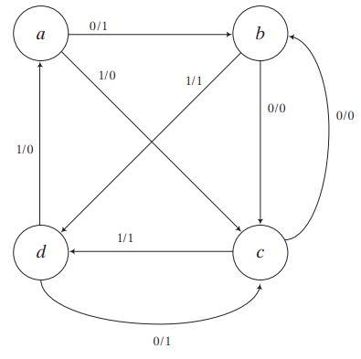

1. Draw the state diagram of the machine described by the Verilog model given below.

module Prob_1 ( output reg y_out, input x_in, clk, reset);

parameter s0 = 2'b00, s1 = 2'b01, s2 = 2'b10, s3 = 2'b11;

reg [1:0] state, next_state;

always @ ( posedge clk, negedge reset) begin

if (reset == 1'b0) state <= s0;

else

state <= next_state;

always @(state, x_in) begin

y_out = 0;

next_state = s0;

case (state)

s0: begin y_out = 0; if (x_in) next_state = s1; else next_state = s0; end

s1: begin y_out = 0; if (x_in) next_state = s2; else next_state = s1; end

s2: begin y_out = 1; if (x_in) next_state = s3; else next_state = s2; end

s3: begin y_out = 1; if (x_in) next_state = s0; else next_state = s3; end

default: next_state = s0;

endcase

end

endmodule

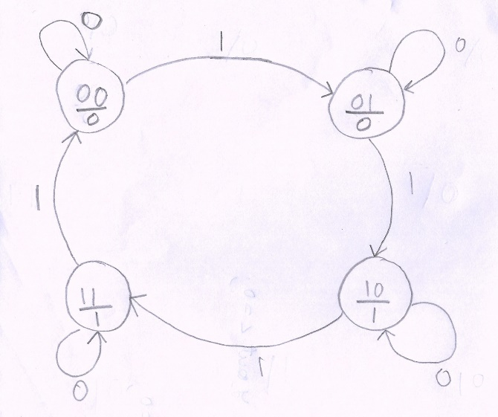

**Self-Practice and self-evaluation**

1. Write a Verilog model of the Moore FSM described by the below state diagram. Develop a test bench and demonstrate that the machine's state transitions and output correspond to its state diagram.

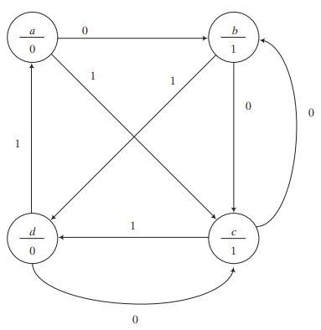

1. Draw the state diagram of the machine described by the Verilog model given below.

module Prob_2 ( output reg y_out, input x_in, clk, reset);

parameter s0 = 2'b00, s1 = 2'b01, s2 = 2'b10, s3 = 2'b11;

reg [1:0] state, next_state;

always @ ( posedge clk, negedge reset) begin

if (reset == 1'b0) state <= s0;

else

state <= next_state;

always @(state, x_in) begin

y_out = 0;

next_state = s0;

case (state)

s0: if x_in = 1 begin y_out = 0; if (x_in) next_state = s1; else next_state = s0; end

s1: if x_in = 1 begin y_out = 0; if (x_in) next_state = s2; else next_state = s1; end

s2: if x_in = 1 if (x_in) begin next_state = s3; y_out = 0; else begin next_state = s2; y_out = 1; end

s3: if x_in = 1 begin y_out = 1; if (x_in) next_state = s0; else next_state = s3; end

default: next_state = s0;

endcase

end

endmodule